Detail of teaching faculty as on 01/11/2017 in R/O Abhilashi University

Department of Pharmacy
Sr. No. | Name of the  Faculty | Subject with  Specialization | Designation/  Post  (Prof. /Asso.  Prof./Asstt. Prof.) | Qualfication | Date of  Appointment in the Univ. | Date of joining in the Univ. | Photo
1 | Dr. C D Khadse | Pharmacy (Pharmacogno sy) | Professor | M. Pharm, Ph.D. | 08/06/2017 | 24/07/17 | 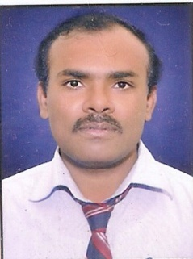
2 | Dr. Gopal Garg | Pharmacy (Pharmaceuti cal Chemistry) | Professor | M. Pharm, Ph.D. | 24/10/2016 | 28/10/2 016 | 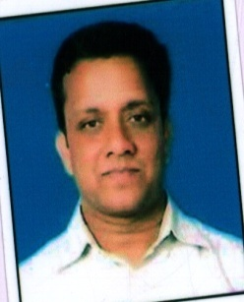
3 | Dr. Sachin Goyal | Pharmacy (Pharmacolog y) | Associate Professor | M. Pharm, Ph.D., PDF (USA) | 30/09/2016 | 01/10/2 016 | 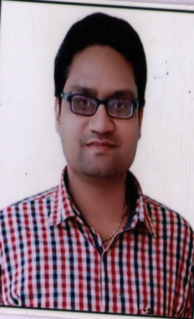
4 | Dr. Jiwan Lavande | Pharmacy (Pharmaceuti cs) | Associate Professor | M. Pharm, Ph.D. | 25/02/2017 | 01/03/2 017 | 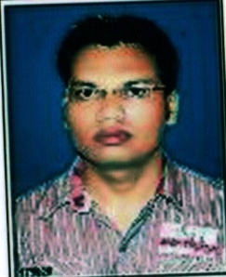
5 | Mr. Deepak Awasthi | Pharmacy (Pharmaceuti cs) | Associate Professor | M. Pharm | 12/12/2011 | 16/12/11 | 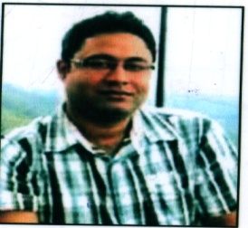
6 | Mr. Ravishankar Yadav | Pharmacy (Pharmacogno sy) | Assistant Professor | M.Pharm | 24/07/17 | 24/07/17 | 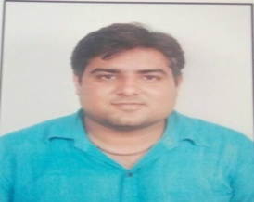
7 | Mrs. Shivali Singla | Pharmacy (Pharmaceuti cs) | Assistant Professor | M. Pharm, Ph.D. | 30/09/2016 | 17/10/2 016
8 | Mr. Abhishek Soni | Pharmacy (Pharmaceuti cs) | Assistant Professor | M. Pharm | 26/02/2015 | 02/03/2 015 | 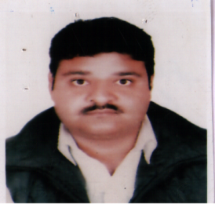
9 | Ms. Shivani Thakur | Pharmacy (Pharmacolog y) | Assistant Professor | M. Pharm | 26/02/2015 | 02/03/2 015 | 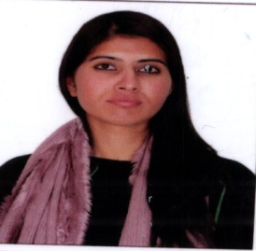
10 | Ms. Sangeeta Verma | Pharmacy (Pharmaceuti cal Chemistry) | Assistant Professor | M. Pharm | 16/12/2016 | 17/12/2 016 | 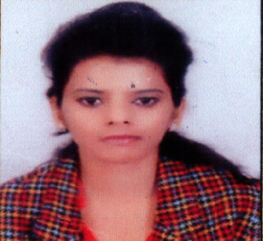
11 | Mrs. Chinu Kumari | Pharmacy (Pharmacolog y) | Assistant Professor | M. Pharm | 30/06/2015 | 01/08/2 015
12 | Mr. Chirag Kapoor | Pharmacy (Pharmaceuti cs) | Assistant Professor | M. Pharm | 25/10/2015 | 02/11/2 015 | 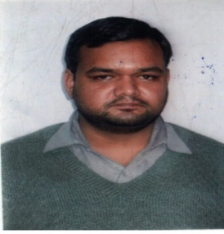
13 | Ms. Abha Vyas | Pharmacy (Pharmaceuti cal Chemistry) | Assistant Professor | M. Pharm | 27/03/2017 | 27/03/2 017 | 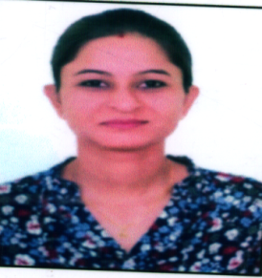
14 | Mrs. Samriti Thakur | Pharmacy (Pharmaceuti cs) | Assistant Professor | M. Pharm | 27/03/2017 | 27/03/2 017 | 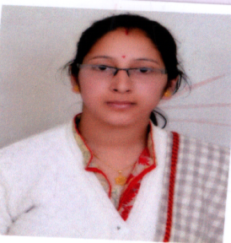
15 | Ms. Bhimi Kumari | Pharmacy (Pharmaceuti cs) | Assistant Professor | M. Pharm | 13/06/2017 | 13/06/2 017 | 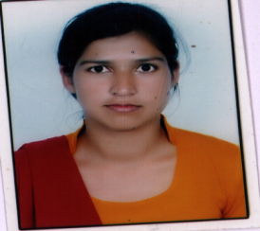
16 | Ms. Anju Bala | Pharmacy (Pharmaceuti cal Analysis) | Assistant Professor | M. Pharm | 24/07/2017 | 24/07/2 017 | 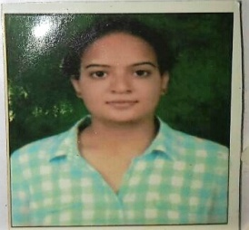
17 | Ms. Supriya Sharma | Pharmacy (Pharmacogno sy) | Assistant Professor | M. Pharm | 01/09/2017 | 01/09/2 017 | 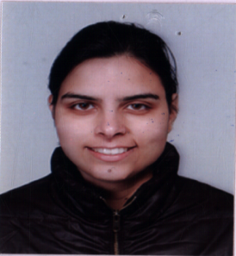
18 | Ms. Reena | Pharmacy (Pharmacolog y) | Assistant Professor | M. Pharm | 11/09/2017 | 11/09/2 017 | 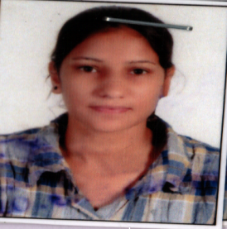
19 | Ms. Chetna Jhagta | Pharmacy (Pharmaceuti cal Chemistry) | Assistant Professor | M. Pharm | 16/10/2017 | 16/10/2 017 | 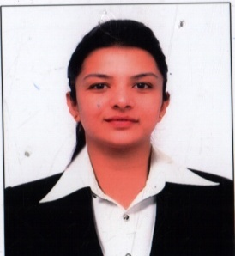
20 | Mr. Deep Sharma | Pharmacy (Pharmaceuti cal Chemistry) | Assistant Professor | M. Pharm | 28/09/2017 | 11/10/2 017
21 | Mr. Amit Sharma | Pharmacy (Pharmaceuti cs) | Assistant Professor | M. Pharm | 24/07/2017 | 24/07/2017 | 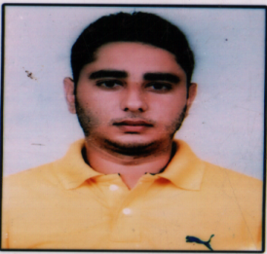
22 | Mrs. Anita Kumari | Pharmacy (Pharmaceuti cs) | Assistant Professor | M. Pharm | 01/09/2017 | 05/09/2 017 | 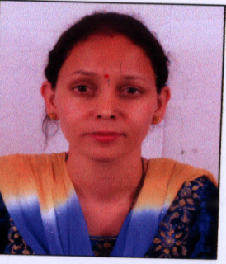
23 | Ms. Nisha Kumari | Pharmacy | Lecturer | B. Pharmacy | 01/09/2016 | 01/09/2016 | 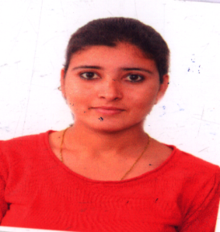
24 | Mrs. Poonam Kumari | Pharmacy | Lecturer | B. Pharmacy | 17/06/2017 | 17/06/2 017 | 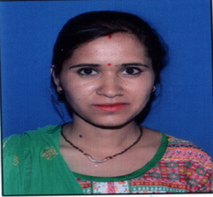

Department: Veterinary Science

Sr. No. | Name of the  Faculty | Subject with  Specialization | Designation/  Post  (Prof. /Asso.  Prof./Asstt. Prof.) | Qualfication | Date of  Appointment in the Univ. | Date of joining in the Univ. | Photo
1 | Dr. Madho Ram Masand | B.V.SC | Professor | B.V.SC | 28.08.2017 | 31.09.201 7
2 | Dr. Insha Kousar kalem | M.V.SC | Assistant Professor | MV.SC | 30.09.2016 | 01.10.201 6  3
3 | Dr. Kunal Pandit | M.V.SC | Assistant Professor | MV.SC | 21.08.2017 | 22.08.201 7 | 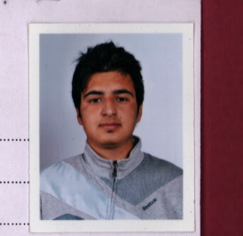
4 | Dr. Brij Vanita | M.V.SC | Assistant Professor | MV.SC | 26.08.2017 | 28.08.201 7 | 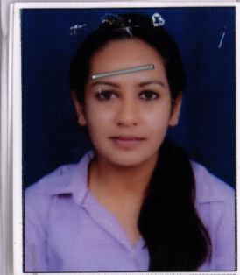
5 | Dr. Tarun Thakur |  | Assistant Professor | B.V.SC | 26.06.2017 | 20.07.201 7 | 