Detail of teaching faculty as on 01/11/2017 in R/O Abhilashi University

Department of Education
Sr. No. | Name of the  Faculty | Subject with  Specialization | Designation/  Post  (Prof. /Asso.  Prof./Asstt. Prof.) | Qualfication | Date of  Appointment in the Univ. | Date of joining in the Univ. | Photo
1 | Mrs. Promila | Education | Professor | M.Phil. Ph.D. Educatio n | 06/08/2015 | 07/08/20 15 | 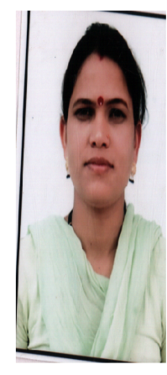
2 | Dr. Rajesh Kumar | Education | Assoc. Professor | M.Sc., M.Ed. M.Phil.(E ducation) | 01/10/2004 | 01/10/20 04

