Detail of Teaching faculty as on 01/11/2017 in R/O Abhilashi University

Department of Engineering & Technology
Sr. No. | Name of the  Faculty | Subject with  Specialization | Designation/  Post  (Prof. /Asso.  Prof./Asstt. Prof.) | Qualfication | Date of  Appointment in the Univ. | Date of joining in the Univ. | Photo
1 | Biplab Kumar Sarkar | Computer Science Engg. | Adjunct Professor (CSE) | Ph.D (CSE) | 22-08-15 | 03-11-15
2 | Ms. Reenu Jaswal | Steganography | Asstt. Prof. (CSE) | M. Tech. (CSE) | 20-07-17 | 24-07-17
3 | Mr. Hemraj Sharma | Computer | Asstt. Prof. (CSE) | MCA | 08-07-17 | 15-07-17 | 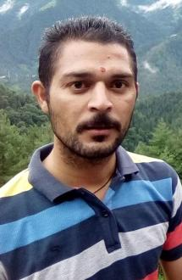
4 | Dr. H.S. Badrinarayan | Mechanical Engg. | Adjunct Professor (ME) | Ph.D(ME) | 03-09-15 | 03-09-15
5 | Er. Chaman Lal | Mechanical Engg. | Asstt. Prof. (ME) | M. Tech. (ME) | 11-08-14 | 19-08-14 | 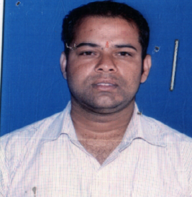
6 | Er. Virender kumar | Production Engg. | Asstt. Prof. (ME) | M. Tech. (ME) | 30-06-15 | 30-06-15
7 | Er. Raj kumar | Production Engg. | Asstt. Prof. (ME) | M. Tech. (ME) | 11-10-17 | 01-11-17 | 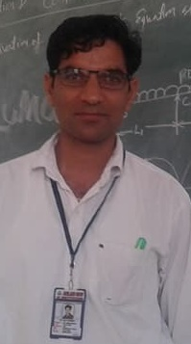
8 | Er.Virender Singh | Industrial Engg. | Asstt. Prof. (ME) | M. Tech. (ME) | 22-07-17 | 24-07-17
9 | Er. Bhaskar Dhiman | Production Engg. | Asstt. Prof. (ME) | M. Tech. (ME) | 15-07-17 | 25-07-17
10 | Er.Dinesh Kumar | Semiconductor Physics | Asstt. Prof. (ME) | M. Sc., M.Tech. | 20-04-17 | 24-07-17 | 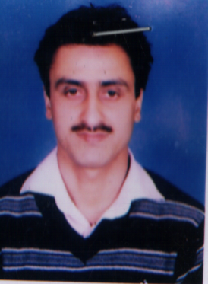
11 | Mrs. Ankita Chaudhary | English | Asstt. Prof. (ME) | M A M.phil | 08-08-17 | 10-08-17 | 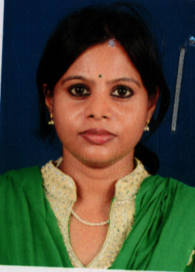
12 | Mrs. Nancy Verma (*) | Human Resource | Asstt. Prof. (ME) | MBA | 30-06-15 | 01-08-15
13 | K.K. Kampani | Civil Engg. | Professor (CE) | Ph.D (CE) | 28-03-17 | 01-04-17
14 | Manoj Kumar | Transportation | Asstt. Prof. (CE) | M. Tech. (CE) | 31-07-15 | 01-08-15
15 | Ms. Sobhika Rana | Structural Engg. | Asstt. Prof. (CE) | M. Tech. (CE) | 21-08-15 | 24-08-15 | 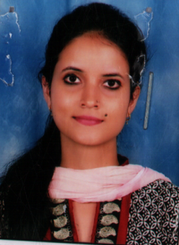
16 | Er. Raman Kumar Sharma | Environmental Engg. | Asstt. Prof. (CE) | M. Tech. (CE) | 14-07-16 | 01-08-16 | 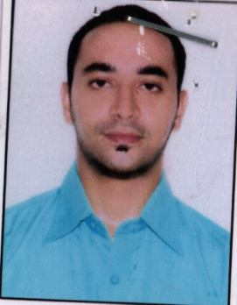
17 | Er. Ruchi Devi | Environmental | Asstt. Prof. (CE) | M. Tech. (CE) | 14-07-16 | 02-08-16 | 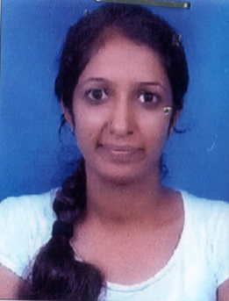
18 | Er. Vishal Pandit | Environmental Engg. | Asstt. Prof. (CE) | M. Tech. (CE) | 11-10-17 | 01-11-17
19 | Gulshan Bharati | Structural Engg. | Asstt. Prof. (CE) | M. Tech. (CE) | 21-08-15 | 24-08-15 | 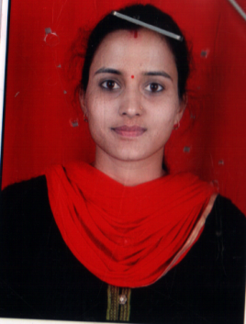
20 | Er. Piyush kumar | Structural Engg. | Asstt. Prof. (CE) | M. Tech. (CE) | 24-08-17 | 25-08-17 | 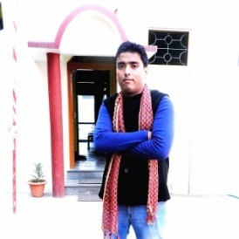
21 | Geetanjali | Mathematics | Asstt. Prof. (CE) | M. Sc. Maths | 08-06-17 | 08-06-17
22 | Mrs. Durga Sharma | English | Asstt. Prof. (CE) | M A | 19-08-17 | 21-08-17 | 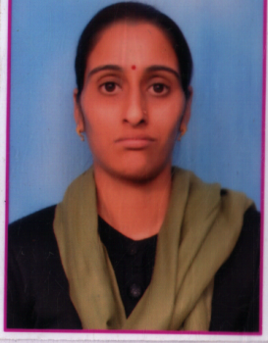
23 | Mr. Sunny Kumar | Chemistry | Asstt. Prof. (CE) | M.Sc. | 22-05-17 | 22-05-17
24- | Omkar Sharma | Physics | Asstt. Prof. (CE) | M.Sc. | 20-08-14 | 21-08-14 | 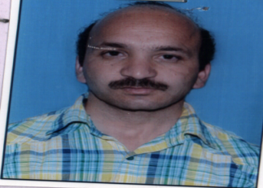

Department: Management

Sr. No. | Name of the  Faculty | Subject with  Specialization | Designation/  Post  (Prof. /Asso.  Prof./Asstt. Prof.) | Qualfication | Date of  Appointment in the Univ. | Date of joining in the Univ. | Photo
1 | Prof A.S. Guleria | Economics | Professor | Ph.D. |  | 20-08-15
2 | Mr Hemant Kapoor | Commerce, Management | Assistant Professor | M.com  M.Phil, MBA | 05-09-14 | 15-09-14 | 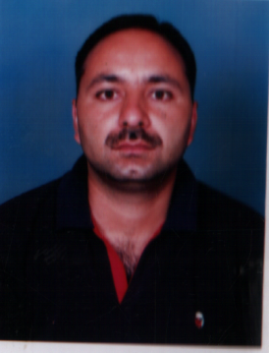
3 | Dr Jatinder Kaur | Management (Finance/Market ing) | Assoc. Professor | MBA, NET, Ph.D. | 22-01-15 | 01-07-16 | 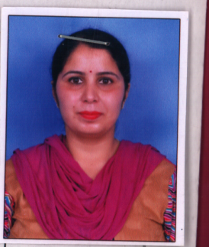
4 | Dr Jyoti Sondhi | Commerce, Management (Finance/Market ing) | Assistant Professor | M.Com, MBA, Ph.D. | 29-07-17 | 31-07-17 | 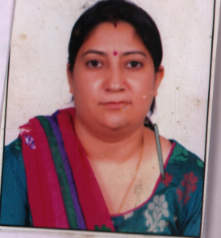
5 | Ms Nancy Verma | Management (HRM/Marketing) | Assistant Professor | MBA | 01-07-15 | 01-07-15

