Detail of teaching faculty as on 01/11/2017 in R/O Abhilashi University

Department of Agriculture
Sr. No. | Name of the  Faculty | Subject with  Specialization | Designation/  Post  (Prof. /Asso.  Prof./Asstt. Prof.) | Qualfication | Date of  Appointment in the Univ. | Date of joining in the Univ. | Photo
1 | Dr. S.S  Masand | Soil Science | Prof. | Ph.D. | 03.08.14 | 11.8.2014 | 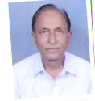
2 | Dr.R.C.  Thakur | Agronomy | Prof. | Ph.D. | 03.08.14 | 11.08. 2014 | 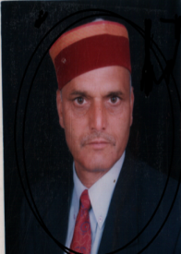
3 | Prof A.S. Guleria | Economics | Prof. | Ph.D. | 15.07.15 | 12.08.2015
4 | Dr. B.S. Deor | Agronomy | Prof. | Ph.D. | 24.08.2015 | 24.08.2015
5 | Dr. J.C. Gupta | Genetics and Plant Breeding | Prof. | Ph.D. | 21.08.2017 | 22.8.2017 | 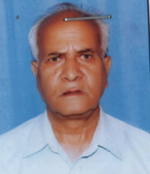
6 | Dr. A.K. Gautam | Plant Pathology | Prof. | Ph.D. | 30.08.2014 | 01.09.2014
7 | Mrs. Ankita  Chaudhary | English | Assoc.Prof. | M. Phil. | 08.08.2017 | 09/08/2017 | 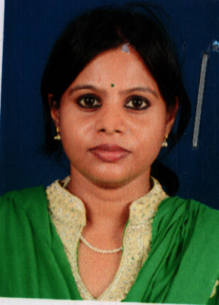
8 | Dr. Aakriti Guleria | Microbiology | Asstt. Prof. | Ph.D. | 28.01.2016 | 15.02.2016 | 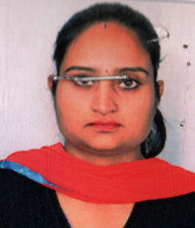
9 | Dr. Vijay | Plant Pathology | Asstt. Prof. | Ph.D. | 24.08.2017 | 25.08.2017 25.08.20
10 | Er. Shatruhan Jaiswal | Agri.  Engg. | Asstt. Prof. | M.Tech. | 20.07.2015 | 01.08.2015
11 | Dr. Nivedita Gupta | Vegetable Science | Asstt. Prof. | Ph.D. | 23.08.2017 | 01.02.2017
12 | Dr. Vineeta Rajput | Horticulture | Asstt. Prof. | Ph.D. | 04.06.17 | 15.07.2017 | 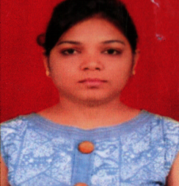
13 | Dr. Navdeep Singh Jamwal | Genetics and Plant Breeding | Asstt. Prof. | Ph.D. | 05.06.2017 | 27.07.2017 | 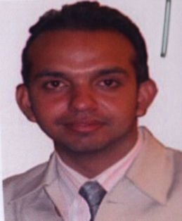
14 | Dr. Jyotika Brari | Entomology | Asstt. Prof. | Ph.D. | 26.08.2016 | 26.08.2016
15 | Dr. Chhavi | Entomology | Asstt. Prof. | Ph.D. | 05.06.2017 | 31/7/2017 | 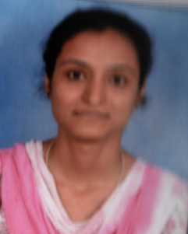
16 | Ms. Mamta | Horticulture | Asstt. Prof. | M.Sc. | 21.08.2017 | 01/09/2 017 17 | 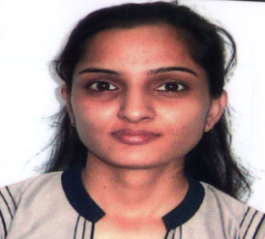
17 | Ms. Chhama | Food Sc. and Technology | Asstt. Prof. | M.Sc. | 09.09.2017 | 11/09/2 017  18 | 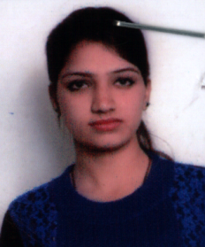
18 | Mr. Anuj Kumar | Agri. Economics | Asstt. Prof. | M.Sc. | 30.07.2016 | 01/08/2 016
19 | Ms. Kanika | Agri. Economics | Asstt. Prof. | M.Sc. | 09.08.2017 | 21/08/2 017 | 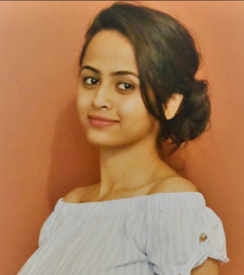
20 | Mrs. Shivani Kaundal | Plant Physiology | Asstt. Prof. | M.Sc. | 27.02.2016 | 03/02/2 016
21 | Ms. Abha Sharma | Agronomy | Asstt. Prof. | M.Sc. | 09.08.2017 | 16/8/20 17
22 | Ms. Parita | Agronomy | Asstt. Prof. | M.Sc. | 10.08.2017 | 16/08/2 017 | 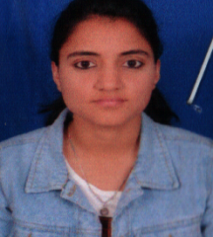
23 | Mr. Karan Verma | Agronomy | Asstt. Prof. | M.Sc. (Ph.D. Persuing) | 25.10.2017 | 26/10/2 017 | 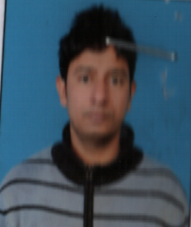
24 | Ms. Nandita Sharma | Agribusiness Management | Asstt. Prof. | M.B.A. | 05.06.2017 | 15/07/2 017
25 | Mr. Ravinder | Soil Science | Asstt. Prof. | M.Sc. (Ph.D. Persuing) | 04.09.2017 | 22/09/2 017
26 | Mrs. Yogita Thakur | Microbiology | Asstt. Prof. | M.Sc. | 28.01.2016 | 03.02.20 16
27 | Dr. Nimit Kumar | Dr. Nimit Kumar | Asstt. Prof. | Ph.D. | 02.03.2017 | 23/03/2 017
28 | Mrs. Durga Sharma | English | Asstt. Prof. | M.Sc | 19.08.2017 | 21/08/2 017 | 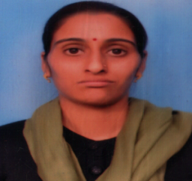
29 | Ms. Geeta Sharma | Mathematics | Asstt. Prof. | M.Sc. | 01.08.2017 | 01/08/2 017 | 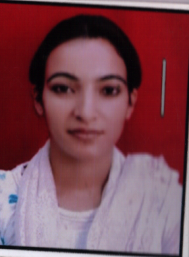
30 | Mr. Hem Raj | Computer | Asstt. Prof. | M.C.A | 08.07.2017 | 15/07/2017 | 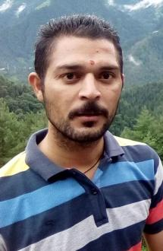
31 | Ms. Suman Kumari | Sociology | Asstt. Prof. | M. A. | 09.12.2016 | 31/08/2017
32 | Ms. Priyanka Rana | Mathematics | Asstt. Prof. | M. Phil. | 08.08.2016 | 09/08/2 016
33 | Mr. Hemant Kapoor | Economics | Asstt. Prof. | M. Phil., MBA | 08.09.2014 | 15/09/2 014 | 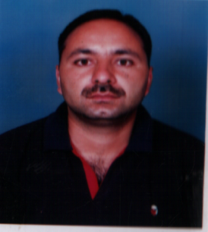
34 | Dr. Om Prakash Chauhan | Chemistry | Asstt. Prof. | Ph.D. | 06.07.2016 | 01/08/2 016 | 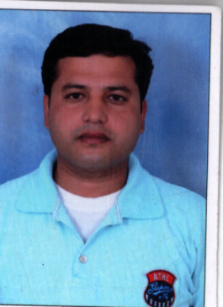
35 | Ms.Urmil Koundal | Math | Asstt. Prof. | M. Phil. | 08.08.2017 | 09/08/2 017
36 | Dr. Insha | Vaterinary Sc. | Asstt. Prof. | M. V. Sc. | 30.09. 2016 | 01/10/2 016 | 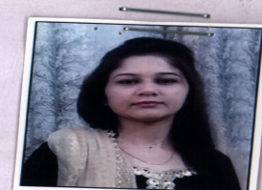
37 | Er. Ruchi | Environmentl Science | Asstt. Prof. | M. Tech. | 04.07.2016 | 02/08/2 016 | 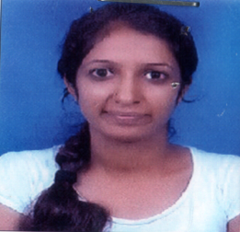

Department: Mathematics
Sr. No. | Name of the  Faculty | Subject with  Specialization | Designation/  Post  (Prof. /Asso.  Prof./Asstt. Prof.) | Qualfication | Date of  Appointment in the Univ. | Date of joining in the Univ. | Photo
1 | Ms.Urmil kaundal | Mathematics(Algebra) | Asstt.Prof | M.SC,M.Phil ,B.Ed | 09-08-2017 | 09-08-2017
2 | Ms.Priyanka Rana | Mathematics(Algebra) | Asstt.Prof | M.SC,M.Phil | 08-08-2016 | 08-08-2016

Department: Chemistry
Sr. No. | Name of the  Faculty | Subject with  Specialization | Designation/  Post  (Prof. /Asso.  Prof./Asstt. Prof.) | Qualfication | Date of  Appointment in the Univ. | Date of joining in the Univ. | Photo
1 | Prof. S. C. Chauhan | Physical Chemistry | Professor | Ph.D. | 03/08/201 4 | 11-08-2015
2 | Prof. S.K. Shukla |  | Professor | Ph.D | 24/10/201 7 | 25/10/20 17
3 | Dr. O. P. Chouhan | Organic Chemistry | Asst.Professor | Ph.D. | 06/07/201 6 | 01-082017
4 | Mr. Akash Datial | Physical Chemistry | Asst.Professor | M.Phil. NET | 16/08/201 7 | 16-082017 | 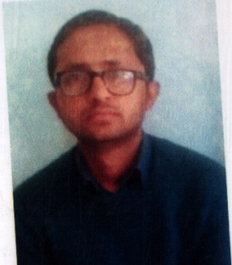

Department: Zoology
Sr. No. | Name of the  Faculty | Subject with  Specialization | Designation/  Post  (Prof. /Asso.  Prof./Asstt. Prof.) | Qualfication | Date of  Appointment in the Univ. | Date of joining in the Univ. | Photo
1 | Dr Neetu Sharma | Zoology (Toxicology and Pharmacolog y) | Assoc. Prof. | Ph.D. | 01.08.2016 | 01.08.20 16 | 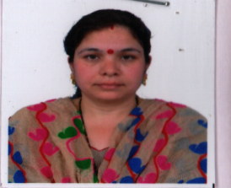
2 | Dr. Nisha Devi | Zoology (Immunopar asitology) | Asstt. Prof. | Ph.D. | 01.08.2016 | 01.08.20 16 | 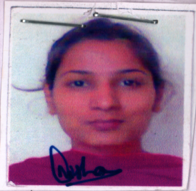
3 | Mr Varun Kumar | Zoology (Entomology) | Asstt. Prof. | M.Phil. | 21.09.2017 | 21.09.20 17
4 | Dr. Muhammad Salim Reshi | (Toxicology and Nano Medicine) | Asstt. Prof. | Ph.D. | 30/08/2017 | 06/09/2 017 | 