Detail of Teaching faculty as on 01/11/2017 in R/O Abhilashi University
Department: Ayurveda (BAMS)
 | Name of the  Faculty | Subject with  Specialization | Designation/  Post  (Prof. /Asso.  Prof./Asstt. Prof.) | Qualfication | Date of  Appointment in the Univ. | Date of joining in the Univ. | Photo
1 | Prof. Dharmendra Kumar Mishra | Swasthvrita | Professor. | B.A.M.S. , M.D. (Kaya Chikitsa) | 7/7/2015 | 20/8/2015 | 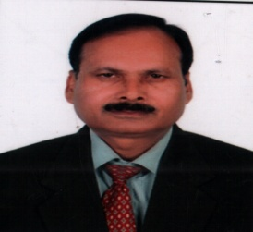
2 | Dr.Saudamani Devi | Kayachikitsa | Associate Professor | M.D. | 26/12/15 | 02/06/15 | 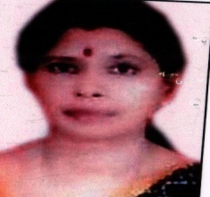
3 | Dr. Dinesh Kumar | Kayachikitsa | Asst. Prof. | M.D. | 24/08/2015 | 19/10/2015 | 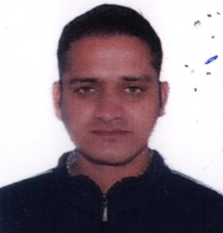
4 | Dr. Prabodh M. Yerawar | Samhinta Sanskrit & Siddhant | Asst. Prof. | M.D. | 02/01/2015 | 02/01/2015 | 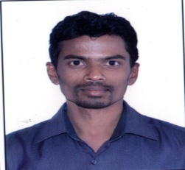
5 | Mr. Shyam Lal | Sanskrit | Asst. Prof. | M.A.  Sanskrit | 01/10/2013 | 01/06/2014 | 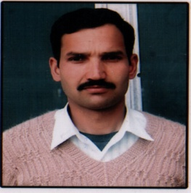
6 | Dr. Pankaj Saklani | Kriya Sharir | Asst. Prof. | M.D. | 09/10/2014 | 09/10/2014 | 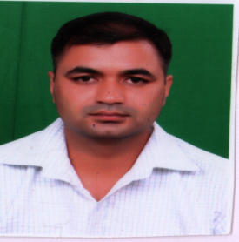
7 | Dr. Vikas Bharmouria | Sharir Rachna | Asst. Prof. | M.D. | 25/05/2015 | 25/05/2015 | 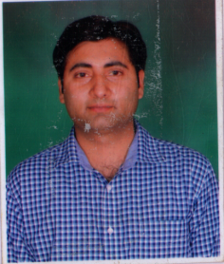
8 | Dr. Sukhwinder Pal Singh | Rasa Shastra & Bhaishjya Kalpana | Associate Professor | M.D. | 29/12/2014 | 29/12/2014 | 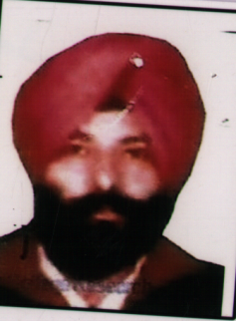
9 | Dr. Rahul Nigam | Rasa Shastra & Bhaishjya Kalpana | Asst. Prof. | M.D. | 15/08/2016 | 13/09/2016 | 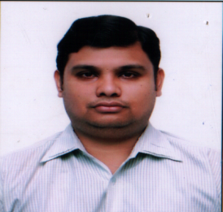
10 | Dr. Kumar S K | Dravyaguna | Associate Prof. | M.D. | 05/01/2016 | 06/01/2016 | 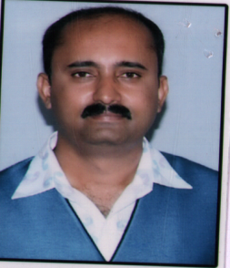
11 | Dr. Malkit Singh | Dravyaguna | Associate Prof. | M.D. | 29/12/2014 | 29/12/2014 | 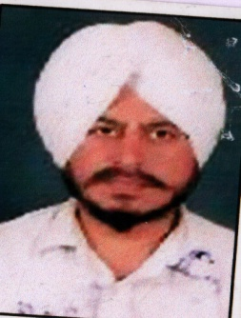
12 | Dr. Vinod Katoch | Dravyaguna | Asst. Prof. | M.D. | 09/01/2015 | 09/01/2015 | 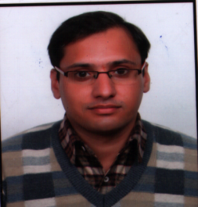
13 | Dr. Anjna Tak | Prasuti Tantra & Stri Roga | Associate Prof. | M.D. | 31/07/2015 | 31/07/2015 | 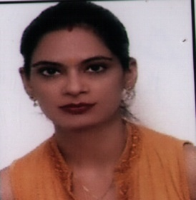
14 | Dr. Vandana | Prasuti Tantra & Stri Roga | Asst. Prof. | M.D. | 09/10/2014 | 09/10/2014 | 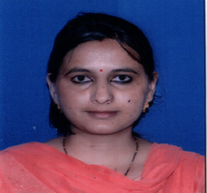
15 | Dr. Shashi Dhara G | Kayachikitsa | Associate Professor | M.D. | 20/01/2016 | 22/01/2016 | 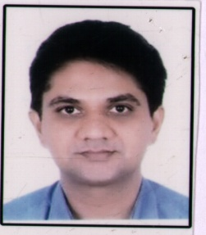
16 | Dr. Monika Sharma | Kayachikitsa | Associate Prof. | M.D. | 16/09/2015 | 02/11/2015 | 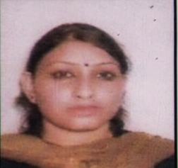
17 | Dr. Priyanka Sharma | Kayachikitsa | Asst. Prof. | M.D. | 17/08/2016 | 01/09/2016 | 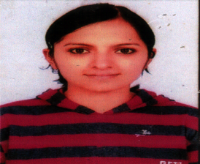
18 | Dr. Ved Prakash | Kayachikitsa | Professor | M.D. | 17/03/2016 | 22/06/2016 | 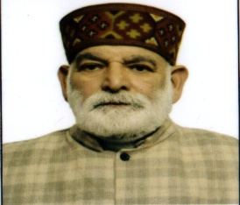
19 | Dr. Abhinav Rathore | Kayachikitsa | Asst. Prof. | M.D. | 28/12/2015 | 01/01/2016 | 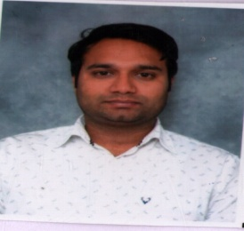
20 | Dr. Rahul Sharma | Shalkaya Tantra | Asst. Prof. | M.D. | 01/04/2016 | 01/04/2016 | 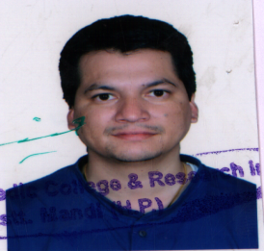
21 | Dr. Rajesh Chaudhary | Kayachikitsa | Associate Professor | M.D. | 17/07/2016 | 13/08/2016 | 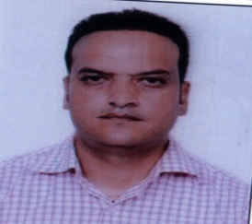
22 | Dr. Sarika V Nehere | Rachana Sharir | Associate Professor | M.D. | 30/08/2016 | 22/09/2016
23 | Dr. Bhappil Sharma | Stri Prastuti | Asst. Prof. | M.D. | 16/01/2017 | 17/01/2017 | 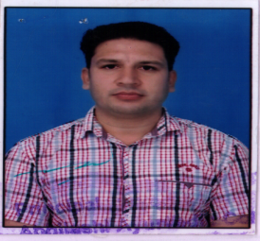
24 | Dr. Munish Sood | Kayachikitsa | Associate Professor | M.D. | 17/07/2016 | 13/08/2016 | 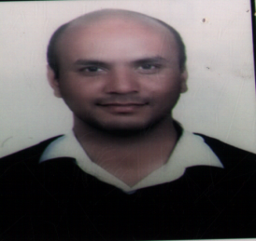
25 | Dr. Uma G Gubbi | Kayachikitsa | Professor | M.D. | 27/09/2016 | 02/12/2016 | 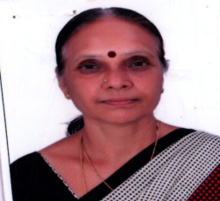
26 | Dr. Gaesh G. Borade | Sharir Rachana | Asst. Prof | M.D. | 01/11/2016 | 23/11/2016 | 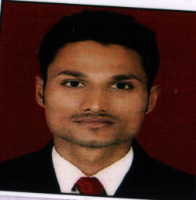
27 | Dr. Yogesh Kumar | Rog Nidan | Associate Professor | M.D. | 01/12/2016 | 02/12/2016 | 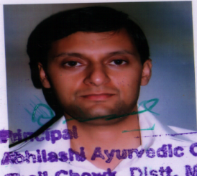
28 | Dr. Dheeraj Govind Jangle | Shalaya Tantra | Associate Professor | M.S. | 17/11/2016 | 29/12/2016
29 | Dr. Manu Verma | Kayachikitsa | Asst. Prof | M.D. | 05/10/2017 | 01/11/2017 | 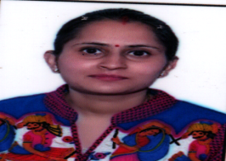
30 | Mr. Vijender Kumar (*) | Yogic Science | Asst. Prof | M.D. | 01/03/2017 | 01/03/2017
31 | Ms. Deepika Sood (*) | Bio-Statistics | Asst. Prof | M.D. | 01/01/2017 | 01/02/2017

Department: Physiotherapy

Sr. No. | Name Of The  Faculty | Subject With  Specialization | Designation/  Post  (Prof. /Asso.  Prof./Asstt. Prof.) | Qualfication | Date Of  Appointment In The Univ. | Date Of Joining In The Univ. | Photo
1 | Dr. Dharmend Ra Kumar Mishra | Dean | Prof | M.D. | 07/07/2015 | 10/08/2015 | 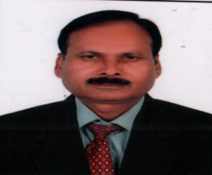
2 | Dr. Amit Masand | Orthopaedics | Associate Prof. | M.P.T | 01/08/2016 | 22/09/2016
3 | Dr. Neha Kaundal | Paediatrics | Assistant Prof. | M.P.T | 01/08/2016 | 01/08/2016 | 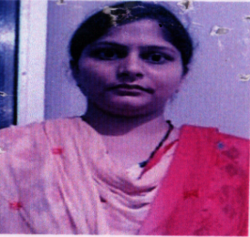
4 | Dr. Manmeet Dhaliwal | Orthopaedics | Assistant Prof. | M.P.T | 01/08/2016 | 01/08/2016
5 | Dr. Harsaran Singh Malhotra | Medicine | Medical Specialist (Part Time) | M.D. | 17/10/2016 | 17/10/2016
6 | Dr.Vishal Dublish | Paediatrics | Pediatrician (Part Time) | MBBS | 24/10/16 | 24/10/16 | 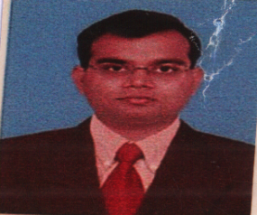
7 | Mrs. Nitasha Chandel | Computer Science | Asistant Prof. | MCA | 01/08/2016 | 01/08/2016 | 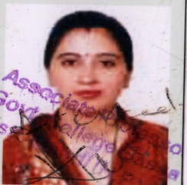

Department: D. Pharmacy (Ayurveda)

Sr. No. | Name Of The  Faculty | Subject With  Specialization | Designation/  Post  (Prof. /Asso.  Prof./Asstt. Prof.) | Qualfication | Date Of  Appointment In The Univ. | Date Of Joining In The Univ. | Photo
1 | Dr. Dharmendr A Kumar Mishra | Dean | Prof | M.D. | 07/07/2015 | 20/08/20 15 | 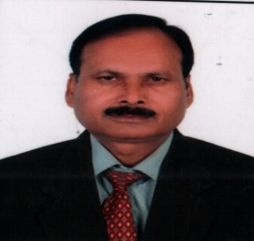
2 | Dr. Chestha | - | A.M.O / Asst. Prof | BAMS | 01/02/2017 | 01/03/2017 | 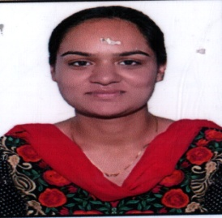
3 | Dr. Archana | - | A.M.O / Asst. Prof | BAMS | 20/09/2017 | 13/10/2017 | 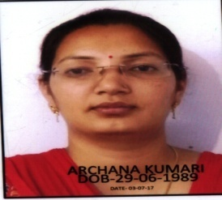
4 | Dr. Shruti | - | A.M.O / Asst. Prof | BAMS | 20/09/2017 | 17/10/2017 | 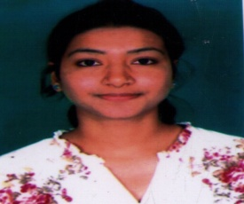
5 | Mr. Vikas Sharma | Pharmacy | Asst. Prof. | M.Pharm | 19/08/2017 | 19/08/2017 | 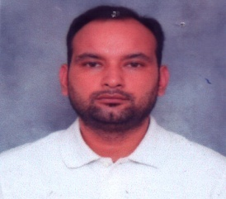
6 | Ms. Neha Kumari | Pharmacy | Pharmacist /Asst. Prof. | M.Pharm | 03/08/2017 | 08/08/2017 | 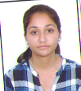
7 | Mr. Amit Sharma | Pharmacy | Pharmacist | B.Pharm | 01/08/2017 | 13/10/2017 | 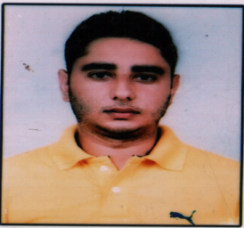
8 | Mrs. Kusuma | Pharmac Ist | Lab Assistant | Diploma In Ayurveda Pharmaci St | 12/09/2017 | 27/09/2017

