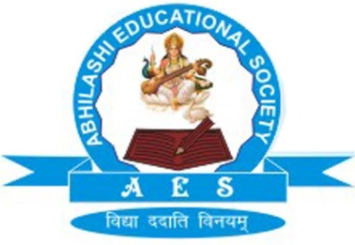 | Abhilashi Ayurvedic College & Research institute  Chail Chwok, Teh. Chachyot, Distt. Mandi (H.P.)  (Department of Abhilashi University)  Ph: 01907-250406, 250407  H.O. Ner Chowk, Tehsil Sadar, Distt. Mandi H.P. 175008  Ph: 01907-250407, 250408, 94180-06520

List of Part Time Teaching Staff in R/o Abhilashi Ayurvedic College & Research Institute (Hospital) Chail Chowk, Tehsil Chachiot, Distt. Mandi (H.P.)

S. No. | Name | Father's Name | PG Qualification | Department | Designation | Permanent  Address | Name of State Board & Registration Number | Code No. | Date of Joining
1 | Mr. Vijender | Sh. Bhuri Singh | MA Yoga Science | Yoga | Assistant Professor | Vill Patha, P.O. Khakaryana, Tehsil Balh, Distt Mandi (H.P.) | NA | NA | 03/01/2017
2 | Ms. Deepika Sood | Sh Om Prakash | M.Sc. Mathematics | Biostatics | Assistant Professor (Biostatican) | Vill Khundiyan, Tehsil Tihri, Distt Kangra(H.P.) | NA | NA | 02/01/2017

