 | Abhilashi Ayurvedic College & Research institute  Chail Chwok, Teh. Chachyot, Distt. Mandi (H.P.)  (Department of Abhilashi University)  Ph: 01907-250406, 250407  H.O. Ner Chowk, Tehsil Sadar, Distt. Mandi H.P. 175008  Ph: 01907-250407, 250408, 94180-06520

List of Teaching Staff in R/o Abhilashi Ayurvedic College & Research Institute (Hospital) Chail Chowk, Tehsil Chachiot, Distt. Mandi (H.P.)

S. No. | Name | Father's Name | Date of Birth | UG Qualification | PG Qualification | Department | Designation | Permanent  Address | Name of State Board & Registration Number | Code No. | Experience | Contact | Date of Joining |  | Photo
 | Prof. Dharmendra Kumar Mishra | Lt. Sh Shiv Kumar Mishra | 04/01/1960  Age: 54yrs | BAMS  Sampurnanand Sanskrit University, Varanasi (UP) | M.D.  Calcutta University Kaya-Chikitsa | Swasthavrita | Dean cum Professor | S.15/79 AK 10 Chhataripur, Shivpur, Varanasi (U.P)  Fax: 01907-250407 | Bhartiya Chikitsa Parishad  33983 | AYUSV0158 | 24.8 Years | 01907- 250407 | 20/08/2015 |  | 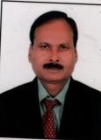
 | Dr. Saudamini Devi | Sh. Maheswara Mohapatra | 5/7/1955 | B.A.M.S GPAM Upri Orissa | MD  Kayachikitsa GPAM Upri Orissa | Swasthavrita | Reader | Puryshotam nagar Sdhamahavira Puri-2 Orissa | Orissa State Council of Ayu. Medicine 2198 | AYUSV0712 | 7.3yrs. | 01907250407 | 2/6/2014 |  | 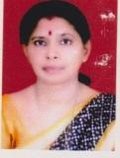
 | Dr. Vikas Rana | Sh. Ramesh Chand | 08/07/1988 | B.A.M.S H.P.U. Shimla | M.D. H.P.U. Shimla | Swasthavrita | Assistant Professor | V.P.O. Sai (Thural) Teh. Palmpur , Distt. Kangra (H.P) 176107 | HP Ayurvedic & Unani Chikitsa Board 4165 | Applied | ---- | 01907250407 | 24/10/2016 |  | 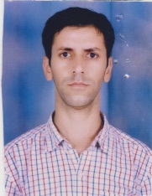
 | Prof.  R. K.  Panigrahi | Sh.  Narasingha Panigrahi | 03/08/1952  Age:  62yrs | BAMS  UU Vani Vihar  Bhubaneswar | M.D.  BHU  Varanasi | Samhinta Sanskrit & Sidhanta | Professor | Pursotam Nagar, Sidhamahavir Puri-2 (Orissa) | OSC, Orissa  1988 | AYUSS0538 | 42yrs | 01907-250406 | 02/06/14 | 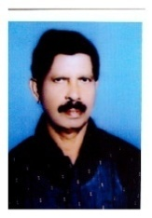
 | Dr.  Prabodh  Moreshwar  Yerawar | Sh. Moreshwar Yerawar | 30/07/1985  29 Years | Maharastra University Health science, Nashik | M.D (Ay.)  HPU  Shimla | Samhinta Sanskrit & Sidhanta | Assistant Prof. | Shri Gajanan General Stores, Near City Post Office, Kasturba Road Chandrapur-442402 (M.S.) | Maharashtra Council of India Medicine  I-63422-A | AYUSS0767 | 2 yrs | 01907-250406 | 02/01/15 | 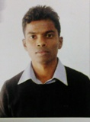
 | Sh. Shyam  Lal | Sh. Goverdhan Singh | 29-05-1979  Age: 35yrs | B.A.  HPU  Shimla | M.A. HPU  Shimla | Sanskrit | Assistant Prof. | VPO Baggi, Teh. Sadar Distt. Mandi (H.P.) 175027 | Not Applicable | AYUSN0156 | 3.5 yrs | 01907-250406 | 01/06/14 | 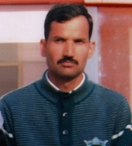
 | Dr. Monika Sharma | Sh. Sushil Sharma | 28/10/1979 | BAMS Bharti Vidyapeeth Pune (MH) | M.D.  Kayachikitsa Bharti Vidyapeeth pune (MH) Kayachikitsa | Kriya Sharir | Reader | Hotel Shrikant Classic Kirpalpur, Nalagharh Distt. Soaln 174101 | Board of Ayurvedic & Unani Systems of Medicine Punjab Chandigarh 9134-I | AYURN0767 | 6.4 yrs | 01907250407 | 02/11/2015 | 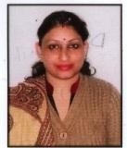
 | Dr. Pankaj Saklani | Sh. Amar Singh Saklani | 11-06-1982  32 Years | B.A.M.S. H.P.U. Shimla | M.D. (Ay.)  H.P.U., Shimla | Kriya Sharir | Assistant Prof. | V..P.O. Nagchala,TehBalh(Nerchowk)  Distt.Mandi H.P.-175021 | HP Ayurvedic & Unani Chikitsa Board  2840 | AYUKS0478 | 2.3 yrs | 01907-250406 | 9/10/14 | 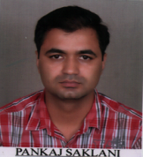
 | Dr. Sarika Vishnu Nehere | Sh. Vishnu Nehere | 12/04/1984 | B.A.M.S  Maharashtra University of Health sciences, Nashik | MD  Maharashtra University of Health sciences, Nashik | Rchana Sharir | Reader | Rh. No. 4, Unity Paradise,Sec. No. 10, Opposite S[pine City Mall, Bhosari,Pune-26 | Maharatra Counsiling Institute Medicene  I-53513-A | AYURS0439 | 5.3 Years | 01907250407 | 22/9/2016 | 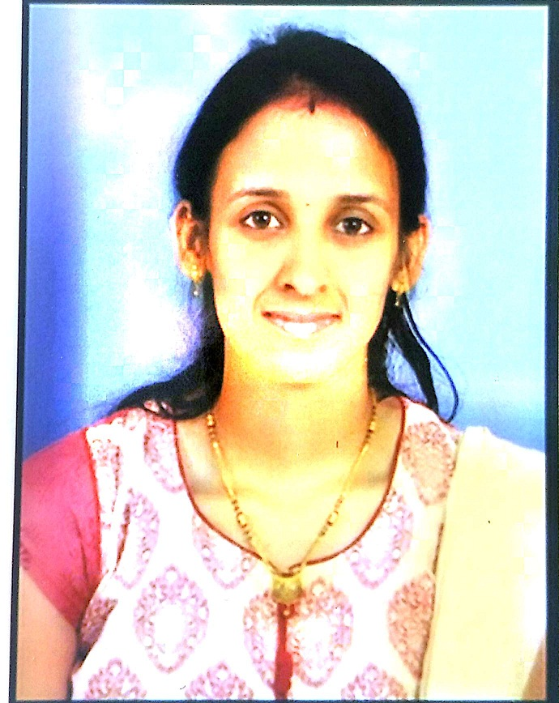
 | Dr. Ganesh G Borade | Sh. Ginyandev Ambadas Borade | 01/03/1984 | B.A.M.S  Maharashtra University of Health sciences, Nashik | MD  Maharashtra University of Health sciences, Nashik | Rchana Sharir | Assistant Professor | Plot No 168,South City,Teesgoan CIDCO, Aurangabad, Maharastra | Maharatra Counsiling Institute Medicene  I-59947-A | AYURS0502 | 2.9 years | 01907250407 | 23/11/2016 | 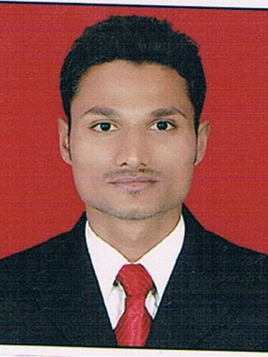
 | Dr. Sukhwinder Pal Singh | Sh. Nirplal Singh | 11/02/1964 | B.A.M.S  Punjabi Univ. Patiala | M.D. (Ay.) Rasa Shastra,  Punjabi Univ. Patiala | Rasa Shastra & Bhaisajya Kalpana | Reader | H.No 639/9, Mahaveer Street , Tehsil Road, Samana 147101 | Board of Ayurvedic & Unani System of Medicine Punjab 3442 | AYURB1021 | 16.2 yrs | 01907-250406 | 29/12/14 | 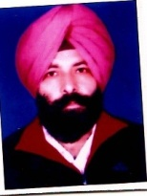
 | Dr. Rahul Nigam | Sh.R.K. Nigam |  | B.A.M.S Bhartiya Vidya peeth , Pune | M.D. K.L.E. University  karnataka | Rasa Shastra & Bhaisajya Kalpana | Assistant  Professor | B-F/F-2 Manjushah Appartment ,Gazibad U.P. | Delhi Bhartiya Chikitsa Parsid  DBCP/A/7242 | Applied | ---- | 01907-250406 | 13/9/2016 | 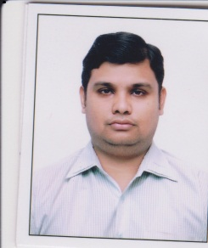
 | Dr. Kumar S. K. | Sh. Kempanna | 08/07/1979 | BAMS Rajiv Gandhi University of Health Science Karnatka | M.D.  Rajiv Gandhi University of Health Science Karnatka Dravyaguna | Agad Tnatra & Vidhi Vigyan | Reader | C/o Manjunath BN #377, Bettahalasur VPO Bangalore 562157 | The Karnataka Ayurvedic & Unani Practitituners Board  16453 | AUAT0467 | 7.4 yrs | 01907-250406 | 06/01/2016 | 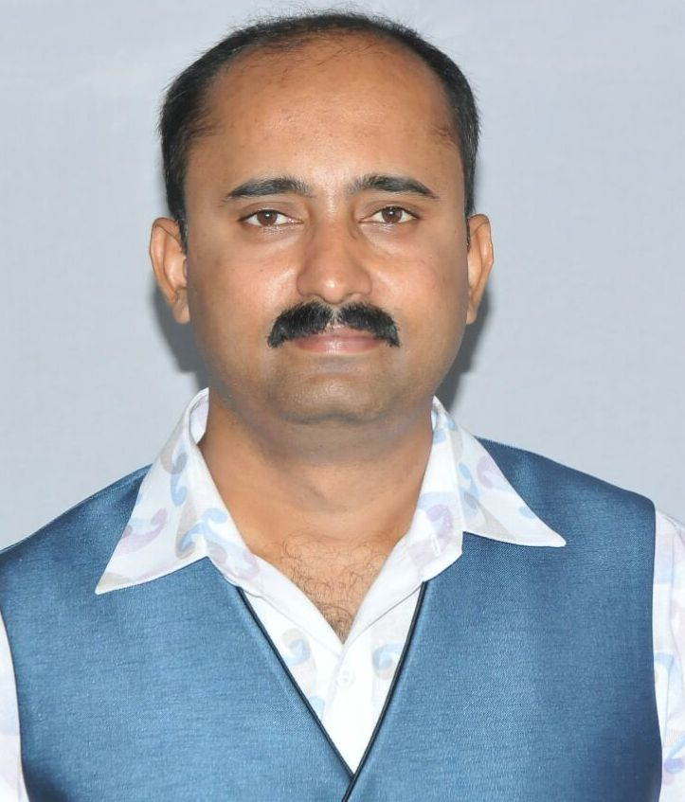
 | Dr. Anoop Kumar | Sh. Pyar Singh Thakur | 20/11/1986 | B.A.M.S Rajiv Gandhi Uni. Of Health Science Karnataka | M.D. (Ayu) Darvyaguna  Rajiv Gandhi Univ. of Health Science, Karnataka | Agad Tantra & Vidhi Vigyan | Assistant  Professor | Vill. Panol ( Hadsar), P.O. Amarpur Teh. Ghumarwin, Distt. Bilaspur Himachal Pradesh 174021 | HP Ayurvedic & Unani Chikitsa Board  4129 | AYUAT0758 | 1.2 yrs | 01907- 250407 | 09/11/2015 | 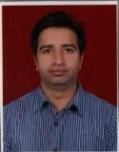
 | Dr. Malkit Singh | Sh. Gian Singh | 01/02/1963 | B.A.M.S. Guru Nanak Dev Univ. Amritsar | M.D. (Ay.) Punjab Univ. Patiala | Dravyaguna | Reader | V.P.O Dakala. Distt. Patiala (Punjab) | Board of Ayurvedic & Unani System of Medicine Punjab 3436 | AYUDG0187 | 15.2 yrs | 01907-250406 | 29/12/14 | 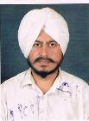
 | Dr. Vinod Katoch | Sh. O. P. Katoch | 09/01/1984 | B.A.M.S Rajiv Gandhi Univ. of Health &  Science (Banglore) | M.D (Ay.)  Rajiv Gandhi Univ. of Health &  Science (Banglore) | Dravyaguna | Assistant  Professor | 156/10 Thanera Mohalla, Tehsil Mandi (H.P) 175001 | HP Ayurvedic & Unani Chikitsa Board  3759 | AYUDG0805 | 2 yrs | 01907-250406 | 09/01/15 | 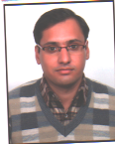
 | Dr. Anjna Tak | Sh. Ramesh Chander | 29/10/1981 | B.A.M.S Baba Farid University of Health & Since | M.D. (Ay.)  H.P.U., Shimla | Prasuti Tantra & Stri Roga | Reader | Vill. Narain, P.O. Bagri, Teh. Theog, Distt. Shimla, H.P | Board of Ayurvedic & Unani system of Medicine ,Punjab 7595 | AYUPS0004 | 7.5 Yrs | 01907-250406 | 31/07/2015 | 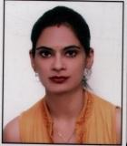
 | Dr. Vandana | Sh. Bhagh Chand | 08/06/1986 | B.A.M.S. H.P.U. Shimla | M.D. (Ay.)  H.P.U., Shimla | Prasuti Tantra & Stri Roga | Assistant Professor | V.P.O. Karjan, Tehsil Manali, Distt. Kullu H.P 175136 | HP Ayurvedic & Unani Chikitsa Board 4000 | AYUPS0751 | 2 yrs | 01907-250406 | 03/01/2015 | 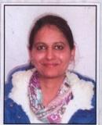
 | Dr. Shashidhara G. | Sh. Gopala Krishna | 26/11/1976 | BAMS Govt. Ayurveda Medical College University of Mysore | M.D. Gopabandhu Ayurveda Mahavidyalaya Puri Orrisa Kayachikitsa | Kaumarabhritya (Balroga) | Reader | H.No. 1446, 13th Main, West of Chord Road, 2nd Stage Mahalakshmipuram Bangalore 560086 | The Karnataka Ayurvedic & Unani Practitioners Board  13023 | AYUKB0593 | 10.6 Yrs | 01907250407 | 22/01/2016 | 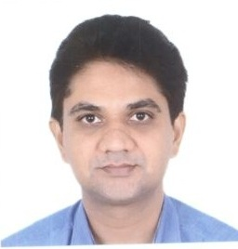
 | Dr. Bhappil Sharma | Sh. Rajeev Sharma | 22/07/1983 | B.A.M.S.Rajiv Gandhi University of Health Science Karnatka | MS  Rajiv Gandhi University of Health Science Karnatka | Bal Roga | Asst. prof. | V.P.O, Dharwar Teh. Sarkaghat, Distt. Mandi H.P. | Ayurved evum Unani Chikitsa Padwati Board Shimla  4348-I | Applied | ------ | 01907250407 | 17/01/2017 | 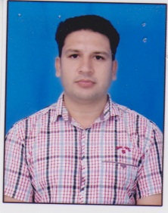
 | Dr. Yogesh Sharma | Sh. D.R. Sharma | 125/11/1979 | B.A.M.S. H.P.U. Shimla | B.A.M.S. H.P.U. Shimla | Rog Nidan eveum Vikiriti Vigyan | Reader | Vill. Kunsal, P.O. Thara, Teh. Baijnath, Distt. Kangra H.P. | HP Ayurvedic & Unani Chikitsa Board 2636 | AYURN0466 | 5.2yers | 01907250407 | 02/12/2016 | 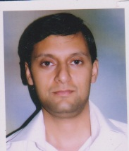
 | Dr. priyanka Sharma | Sh.Puran Chand Sharma | 19/04/1989 | BAMS A.L.N. Rao Memorial Ayurvedic Medical College and Hospital Koppa (Banglore) | M.D.  Kayachikitsa S.D.M. College of Ayurveda Udupi RGUHS Banglore | Rog Nidan eveum Vikiriti Vigyan | Assistant Professor | D/o Sh. Smt. Chanderkanta Sharma,Nursing Sister, Department of cardiology, I.G.M.C., Shimla | Ayurvedic evum unani Chikitsa Paddati Board  4481-I | Applied | ----- | 01907250407 | 01/09/2016 | 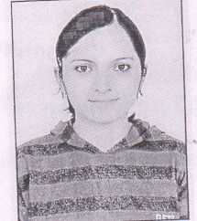
 | Dr. Uma G Gubbi | W/O Dr. H. Mrythyunjapappa | 17/03/1955 | B.A.M.S Banglore University | M.D.  Rajiv Gandhi University of Health Science, Karnataka | Kayachikitsa | Professor | Flat No. SF4 Prakruti elite apartyments, Praskuriti elites Road , Channasandra, Srinivasapura, Banglore 560098 | Karnatka Ayurvedic evum unani Board 2109 | AYUKC0166S | 10.7 years | 01907250407 | 02/12/2016 | 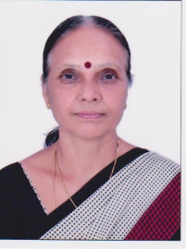
 | Dr. Munish Sood | Sh. Desh Bandhu Sood | 07/02/1981 | BAMS  H.P.U.  Shimla | MD  H.P.U. Shimla | Kayachikitsa | Reader | Chinypurni Niwas, Near RKMV, Long Wood,  Shimla (H.P.) 17001 | Ayurved evum Unani Chikitsa Padwati Board Shimla  2644 | AYUKC0793 | 7 years | 01907250407 | 13/8/2016 | 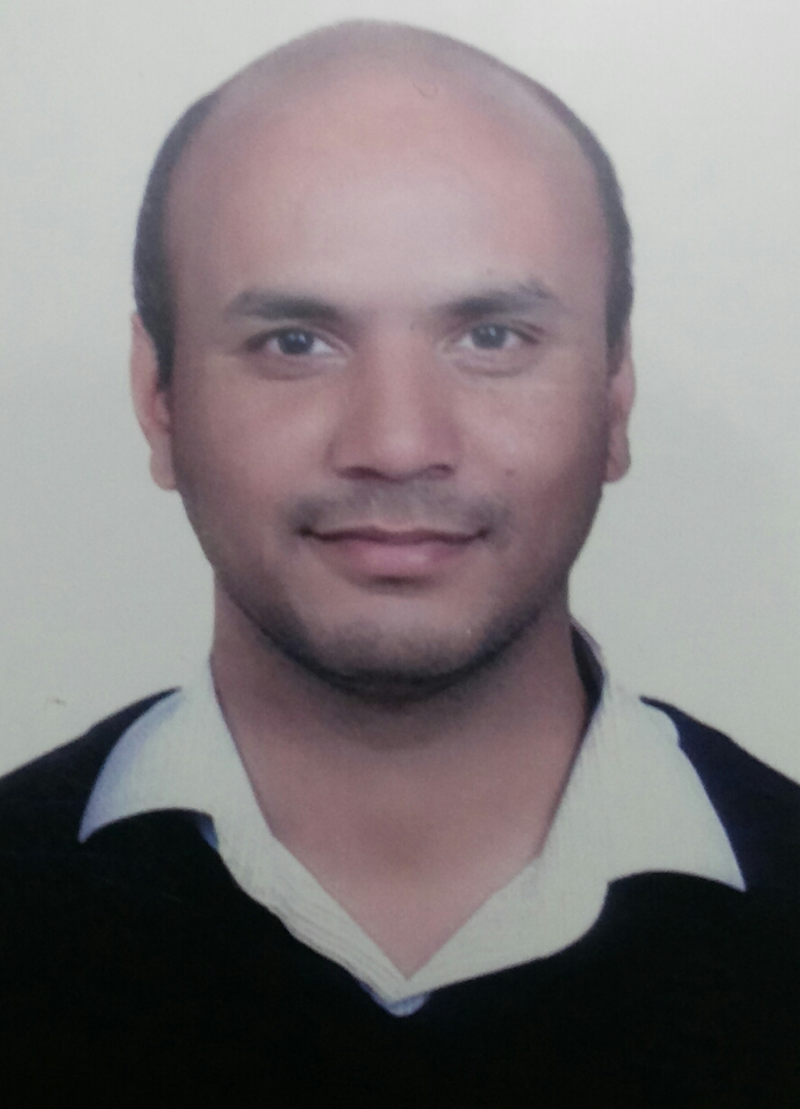
 | Dr. Dinesh Kumar | Sh. Mast Ram | 26/04/1987 | B.A.M.S H.P.U. Shimla | M.D. H.P.U. Shimla | Kayachikitsa | Assistant Professor | V.P.O. Dawahan, Teh. Kotli, Distt. Mandi (HP) | HP Ayurvedic & Unani Chikitsa Board 4009 | AYUSV0667 | 1.3n yrs | 01907250407 | 19/10/2015 | 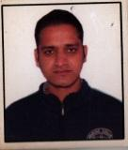
 | Dr. Ved Prakash Sharma | Sh. Lachman Dutt Sharma | 04/03/1953 | GAMS  Punab state Faculty of Ayurved and Unani Systemm of Medicine, Chandigarh | MD  Gujrat Ayurved University | Panchkarma | Professor | Near Petrol Pump, Tehsil Baijnath,Distt. Kangra, (H.P) 176115 | Ayurved evum Unani Chikitsa Padwati Board Shimla  564 | AYUPK0580 | 34 years | 01907250407 | 22/06/2016 | 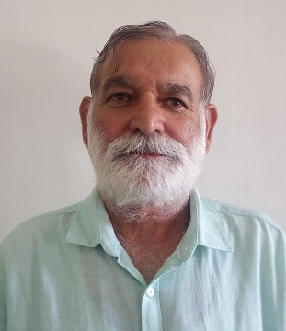
 | Dr. Abhinav Rathore | Dr. Yogender Singh Rathore | 30/09/1987 | BAMS  Rajiv Gandhi University of Health Science Karnatka | MD  Rajiv Gandhi University of Health Science Karnatka | Panchkarma | Asst. Prof. | Adarsh Colony,Garoru, Tehsil & P.O JoginderNagar, Distt. Mandi H.P. 175015 | Ayurved evum Unani Chikitsa Padwati Board Shimla  4055 | AYUPK0724 | 1.11 yrs | 01907250407 | 01/01/2016 | 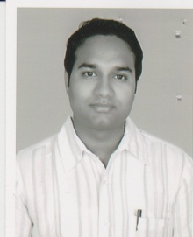
 | Dr. Dhiraj Govido Jangale | Sh. Govind Janglee | 13/05/1982 | B.A.M.S.Maharastra University Health science, Nashik | M.D. University of Pune | Shalya Tantra | Reader | Flat No. 10, Samira Heights, Dhore Nagar, Juni Sangavi,Pune 411017 | Maharashtra Council of India Medicine  I-47914-A | AYUST0617 | 7.1 years | 01907250407 | 16/12/2016 | 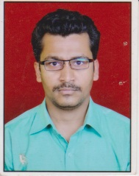
 | Dr. Vikas Bharmouria | Sh. H.R. Bhrmouria | 26/12/1986 | B.A.M.S. H.P.U. Shimla | M.S. (Ay.) H.P.U. Shimla | Shalya Tantra | Assistant professor | House No. 196/10, Thanera Mohalla, Tehsil & Dstt. Mandi H.P 175001 | HP Ayurvedic & Unani Chikitsa Board 4010 | AYURS0886 | 1.7 yrs | 01907-250406 | 25/05/15 | 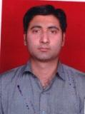
 | Dr. Rajesh Chaudhary | Late Sh. Subash Chander Chaudhary | 25/02/1976 | B.A.M.S. Baba Fraid University of Health Science | M.D. H.P.U. Shimal | Shalakya Tantra | Reader | H.No. 3944, Street Krishana, Katra Khazana, Amritsar Punjab | Board of Ayurvedic evum Unani System of Medicine, Punjab  7546 | applied | 5.1 years | 01907-250406 | 01/04/2016 | 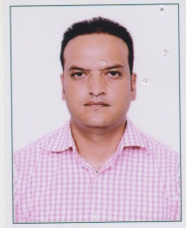
 | Dr. Rahul | Sh. K.L. Sharma | 06/01/1986 | B.A.M.S  Baba Fraid University of Health Science | MD  Rajiv Gandhi University of Health Science Karnatka | Shalakya Tantra | Asst. Prof. | House No.S-4/87, BBMB Colony SunderNagar, Distt. Mandi (H.P) | Ayurved evum Unani Chikitsa Padwati Board Shimla  2644 | Applied | ---- | 9816386476 | 01/04/2016 | 