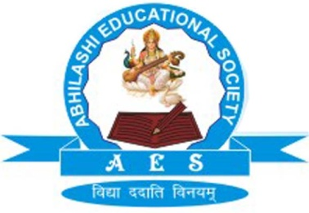 | Abhilashi Ayurvedic College & Research institute  Chail Chwok, Teh. Chachyot, Distt. Mandi (H.P.)  (Department of Abhilashi University)  Ph: 01907-250406, 250407  H.O. Ner Chowk, Tehsil Sadar, Distt. Mandi H.P. 175008  Ph: 01907-250407, 250408, 94180-06520

Details of the result in R/o Abhilashi Ayurvedic College and Research Institute (Hospital) on October 2016.

Sr. No. | Name of Course | Total Students Appeared | Total Students Passed | Students Re-Appear | Year Back
1. | BAMS 1st Prof. | 60 | 45 | 15 | Nil
2. | BAMS 2nd Prof. | 58 | 42 | 16 | Nil

