Date:25/01/2017

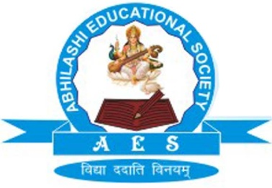 | Abhilashi Ayurvedic College & Research institute  Chail Chwok, Teh. Chachyot, Distt. Mandi (H.P.)  (Department of Abhilashi University)  Ph: 01907-250406, 250407  H.O. Ner Chowk, Tehsil Sadar, Distt. Mandi H.P. 175008  Ph: 01907-250407, 250408, 94180-06520
Detailed Status of Recognition of BAMS Course

Sr. No. | Name of Course | Sanctioned Intake | CCIM, New Delhi | Abhilashi University, Chailchowk, Distt. Mandi (HP)
1 | Bachelor of Ayurvedic Medicine & Surgery (BAMS) | 60 (Seats) | Letter of Permission Received vide letter No. F. No. R. 12011/14/2013-EP(IM-I) Dated 20/10/2014 and F.No.R-12011/14/2013-EP(IM-1) Dated 24/07/2015,  Vide Letter No. R.12011/14/2013- EP(IM-1) for (2016-17) dated 29/09/2016 | Govt. of Himachal Pradesh Vide Letter EDN-A-Ka(9)2014-Abhilashi Dated 14 August 2014 approved Bachelor of Ayurvedic Medicine & Surgery Deptt. Of Abhilashi University with intake of 60 seats, Himachal Pradesh Private Education Institution Regulatory Commission, Shimla, vide letter No. HP-PERC/CA/Abhilashi/2015-16-1641 dated 23/12/2014 approved BAMS course department of Abhilashi University for the Session 2015-16 and vide letter No. No. HP-PERC/CA/Abhilashi/2016-17-2332 dated 31/12/2015 for the session 2016-17.  For the session 2017-18  HP-PERC/CA/Abhilashi/2017-18-3447 dated 30/12/2016

