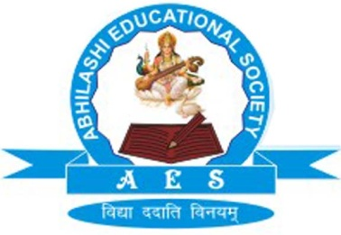 | Abhilashi Ayurvedic College & Research institute  Chail Chwok, Teh. Chachyot, Distt. Mandi (H.P.)  (Department of Abhilashi University)  Ph: 01907-250406, 250407  H.O. Ner Chowk, Tehsil Sadar, Distt. Mandi H.P. 175008  Ph: 01907-250407, 250408, 94180-06520

Details of Affiliated University

Name of the University | Abhilashi University, Chailchowk, Distt. Mandi (HP) | 01907-250406, 250408, 250011, 250407
Name of the Vice-Chancellor | Prof. H.S. Banyal | 01907-250015
Name of the Registrar | Major J. C. Patial | 01907-250011

