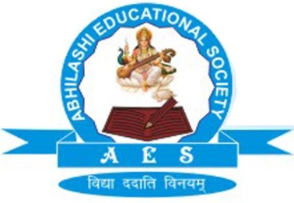 | Abhilashi Ayurvedic College & Research institute  Chail Chwok, Teh. Chachyot, Distt. Mandi (H.P.)  (Department of Abhilashi University)  Ph: 01907-250406, 250407  H.O. Ner Chowk, Tehsil Sadar, Distt. Mandi H.P. 175008  Ph: 01907-250407, 250408, 94180-06520

DETAILS OF PRINCIPAL AND MEDICAL SUPERINTENDENT

S. No. | Name | Father's Name | Date of Birth/ Age | UG Qualification | PG Qualification | Subject | Designation | Permanent  Address | Name of State Board & Registration Number | Photograph | Date of Joining
1 | Prof. Dharmendra Kumar Mishra | Lt. Sh Shiv Kumar Mishra | 04/01/1960  Age: 54yrs | BAMS  Sampurnanand Sanskrit University, Varanasi (UP) | M.D.  Calcutta University Kaya-Chikitsa | Kayachikitsa | Dean cum Professor/MS | S.15/79 AK 10 Chhataripur, Shivpur, Varanasi (U.P)  Fax: 01907-250407 | Bhartiya Chikitsa Parishad  33983 | 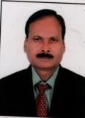 | 20/08/2015

